**Chennai-pondi-kanyakumari**

Here's a detailed itinerary for a 7-day trip to Tamil Nadu covering Chennai, Mahabalipuram, Pondicherry, Thanjavur, Madurai, Rameswaram, and Kanyakumari, including approximate timings:

**Day 1: Chennai**

* **Morning (9:00 AM - 1:00 PM):** Explore Marina Beach, Kapaleeshwarar Temple.
* **Afternoon (1:00 PM - 2:30 PM):** Lunch in Mylapore.
* **Afternoon (3:00 PM - 6:00 PM):** Visit Government Museum and Egmore Museum.
* **Evening (7:00 PM onwards):** Dinner and overnight stay in Chennai.
* 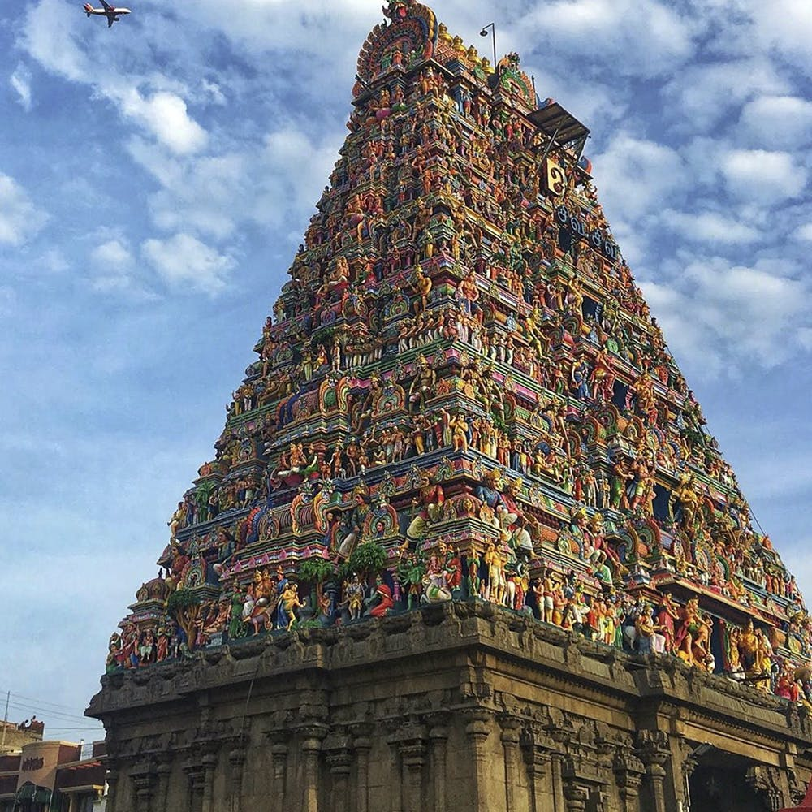

**Day 2: Mahabalipuram**

* **Morning (8:00 AM - 12:00 PM):** Drive to Mahabalipuram.
* **Morning (12:30 PM - 2:00 PM):** Lunch in Mahabalipuram.
* **Afternoon (2:30 PM - 5:30 PM):** Visit Shore Temple, Pancha Rathas, and Arjuna's Penance.
* **Evening (6:00 PM onwards):** Relax on the beach, dinner in Mahabalipuram.

**Day 3: Pondicherry**

* **Morning (9:00 AM - 12:00 PM):** Drive to Pondicherry.
* **Morning (12:30 PM - 2:00 PM):** Lunch in the French Quarter.
* **Afternoon (2:30 PM - 5:30 PM):** Explore Auroville and Aurobindo Ashram.
* **Evening (6:00 PM onwards):** Dinner at a beachside cafe.

**Day 4: Thanjavur**

* **Morning (9:00 AM - 1:00 PM):** Drive to Thanjavur.
* **Afternoon (1:00 PM - 2:30 PM):** Lunch in Thanjavur.
* **Afternoon (3:00 PM - 6:00 PM):** Visit Brihadeeswarar Temple and Thanjavur Palace.
* **Evening (7:00 PM onwards):** Explore local markets, dinner in Thanjavur.

**Day 5: Madurai**

* **Morning (8:00 AM - 12:00 PM):** Drive to Madurai.
* **Morning (12:30 PM - 2:00 PM):** Lunch in Madurai.
* **Afternoon (2:30 PM - 5:30 PM):** Visit Meenakshi Amman Temple and Thirumalai Nayakkar Palace.
* **Evening (6:00 PM onwards):** Attend the Aarti ceremony, dinner in Madurai.
* 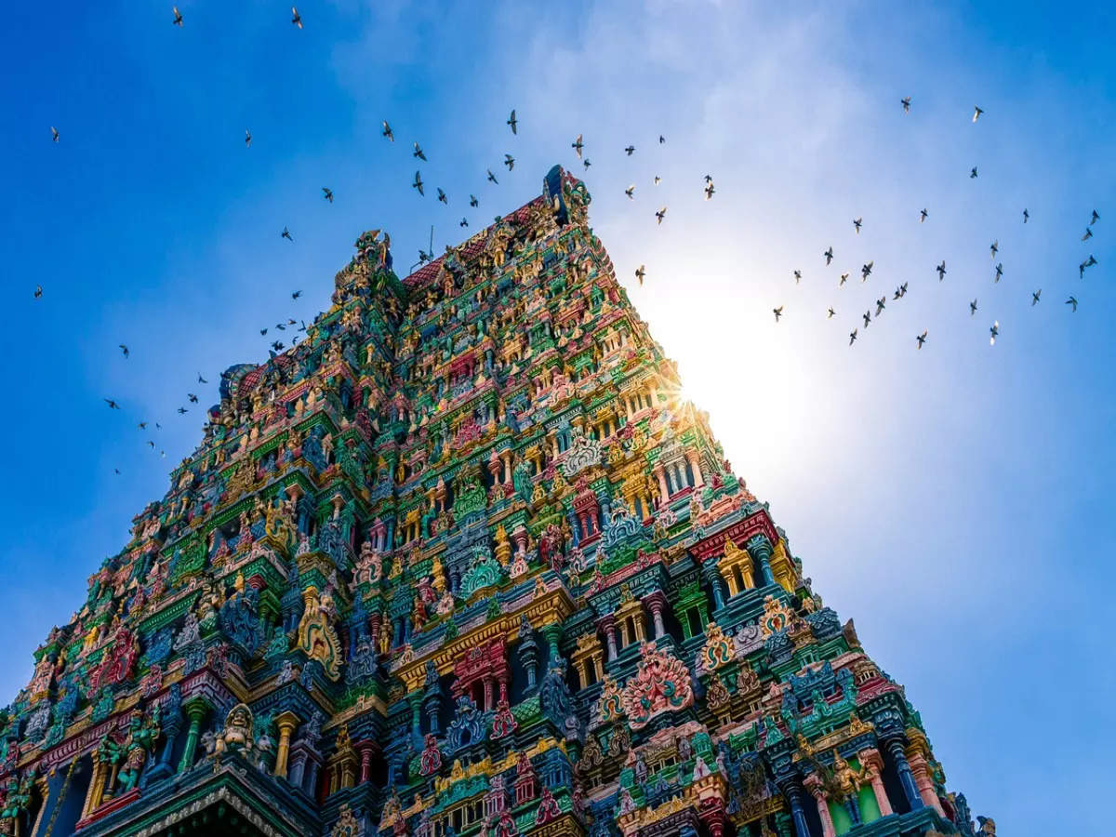

**Day 6: Rameswaram**

* **Morning (8:00 AM - 11:00 AM):** Drive to Rameswaram.
* **Morning (11:30 AM - 1:30 PM):** Visit Ramanathaswamy Temple.
* **Afternoon (2:00 PM - 4:30 PM):** Explore Dhanushkodi and Pamban Bridge.
* **Evening (5:00 PM onwards):** Dinner in Rameswaram.

**Day 7: Kanyakumari**

* **Morning (8:00 AM - 12:00 PM):** Drive to Kanyakumari.
* **Morning (12:30 PM - 2:00 PM):** Lunch in Kanyakumari.
* **Afternoon (2:30 PM - 5:30 PM):** Visit Vivekananda Rock Memorial and Thiruvalluvar Statue.
* **Evening (6:00 PM - 7:30 PM):** Explore Kanyakumari Beach and witness the sunset.
* **Evening (8:00 PM onwards):** Dinner and departure.
* 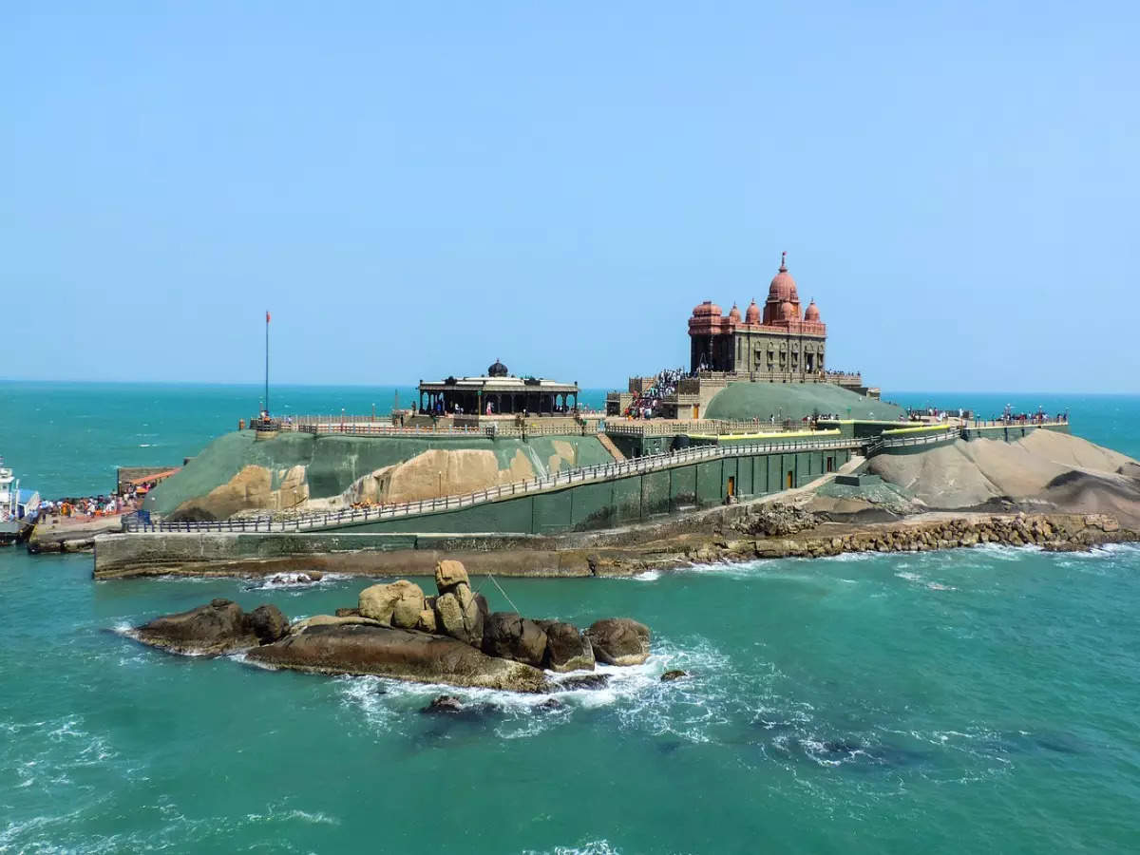

Adjust the timings based on your preferences and actual travel conditions. Note that travel times may vary depending on traffic and road conditions. Check for any travel restrictions or specific guidelines before planning your trip.